TEI480T+How to configurate VPN settings
Product line: Router Question category: Function configurations

- VPN
A virtual private network (VPN) enables a host computer to send and receive data across shared or public networks as if it were a private network with all the functionality, security and management policies of the private network.

PPTP is a protocol for VPN, we can use it to set up a private network between two different networks.
The details for PPTP settings are as follows:

Step 1:
- Create PPTP server
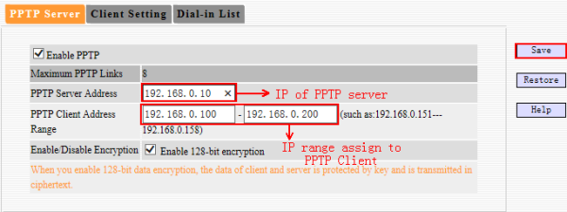

(2) Create User Name and Password for Client
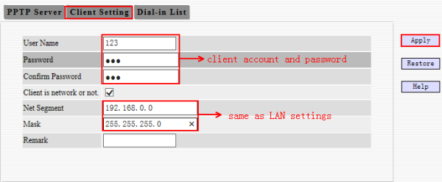

Step 2: Create PPTP Client on TEI480T+
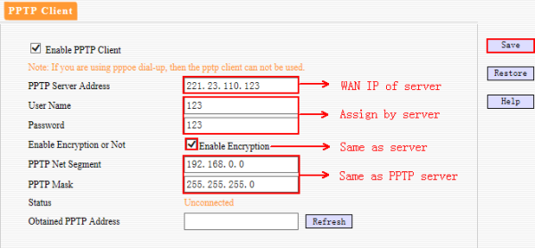

Step 2: Create PPTP Client on PC(windows 7)
Notice: do it step by step.
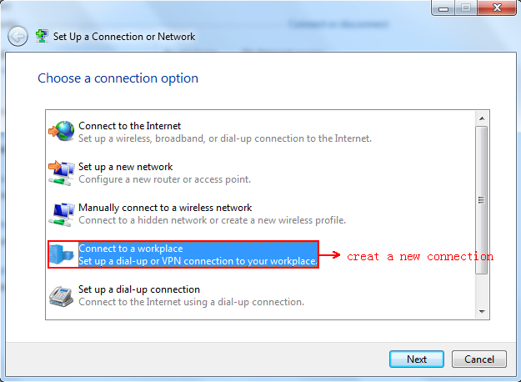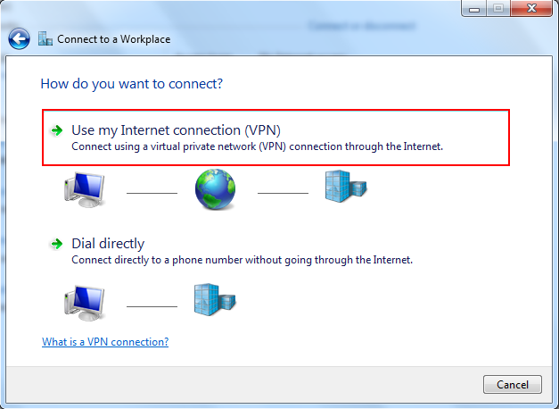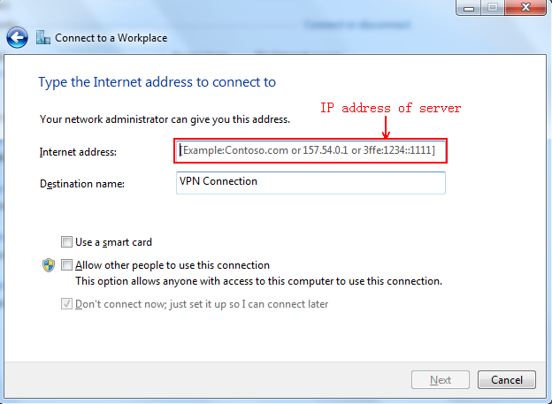
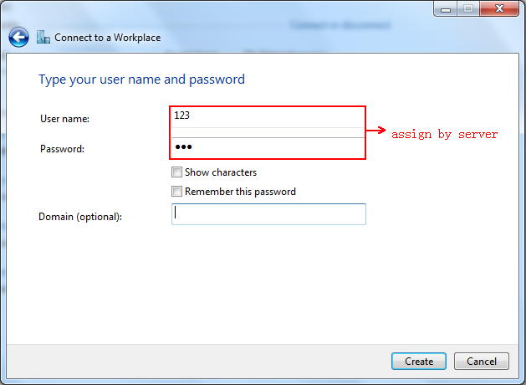
After you finished those two steps, you will be the same network as the server.

